**Integrating Expense Tracking with AI-Driven Investment Recommendations**

## A PROJECT REPORT

***Submitted by,***

**Abdul Aman Khan - 20211CIT0046**

**Rehan Ashraf - 20211CIT0051**

**Mihir Suman - 20211CIT0088**

### *Under the guidance of,*

**Dr. Shanthi S**

***in partial fulfillment for the award of the degree of***

**BACHELOR OF TECHNOLOGY**

**IN**

**COMPUTER SCIENCE AND ENGINEERING -INTERNET OF THINGS**

**At**



**PRESIDENCY UNIVERSITY**

**BENGALURU**

**JANUARY 2025**

**PRESIDENCY UNIVERSITY**

**SCHOOL OF COMPUTER SCIENCE AND ENGINEERING**

**CERTIFICATE**

This is to certify that the Project report **“Integrating Expense Tracking with AI-Driven Investment Recommendations”** being submitted by “**Abdul Aman Khan, Rehan Ashraf, Mihir Suman**” bearing roll number(s) “**20211CIT0046, 20211CIT0051, 20211CIT0088**” in partial fulfillment of the requirement for the award of the degree of Bachelor of Technology in Computer Science and Engineering is a bonafide work carried out under my supervision.

|  |  |
| --- | --- |
| **Dr. Shanthi S**  Associate Professor  School of CSE&IS  Presidency University | **Dr. Anandraj SP**  Prof & HOD – CIT, CCS  School of CSE&IS  Presidency University |

|  |  |  |
| --- | --- | --- |
| **Dr. L. SHAKKEERA**  Associate Dean  School of CSE  Presidency University | **Dr. MYDHILI NAIR**  Associate Dean  School of CSE  Presidency University | **Dr. SAMEERUDDIN KHAN**  Pro-VC School of Engineering  Dean -School of CSE&IS  Presidency University |

**PRESIDENCY UNIVERSITY**

**SCHOOL OF COMPUTER SCIENCE AND ENGINEERING**

**DECLARATION**

We hereby declare that the work, which is being presented in the project report entitled **Integrating Expense Tracking with AI-Driven Investment Recommendations** in partial fulfillment for the award of Degree of **Bachelor of Technology** in **Computer Science and Engineering - Internet of Things**, is a record of our own investigations carried under the guidance of **Dr. Shanthi S, Associate Professor at School of Computer Science Engineering & Information Science, Presidency University, Bengaluru.**

We have not submitted the matter presented in this report anywhere for the award of any other Degree.

|  |
| --- |
| Abdul Aman Khan **20211CIT0046 ___________________**  Rehan Ashraf **20211CIT0051 ___________________**  Mihir Suman **20211CIT0088 ___________________** |
| **ABSTRACT**  The Expense Tracker is a comprehensive financial management application designed to streamline expense tracking and budgeting for individuals and businesses. Leveraging the power of the MERN stack - MongoDB, Express.js, React, and Node.js - this application provides a seamless and efficient solution for managing financial transactions.  The backend, powered by Node.js and Express.js, ensures secure and fast data handling through RESTful APIs. MongoDB, a NoSQL database, is employed to store and retrieve financial data, offering flexibility and scalability as the user base grows. On the front end, react is utilized to create a dynamic and responsive user interface, facilitating a smooth user experience.  Core functionalities include user authentication for secure and personalized access, secure expense logging to maintain accurate financial records, category management and budget tracking for effective financial organization, and interactive charts offering real-time insights into spending patterns. A key innovation of the application is the PennyDrop feature, which leverages user income and expense data to provide personalized investment suggestions. Using data-driven algorithms, PennyDrop empowers users to make informed financial decisions by aligning their income with tailored investment opportunities.  This integration of expense tracking with actionable investment insights creates a holistic platform for financial management. The application is designed to be scalable, maintainable, and user-friendly, making it an ideal solution for individuals and businesses seeking an efficient tool for managing their finances and optimizing their investments. |
|  |

**ACKNOWLEDGEMENT**

First of all, we indebted to the **GOD ALMIGHTY** for giving me an opportunity to excel in our efforts to complete this project on time.

We express our sincere thanks to our respected dean **Dr. Md. Sameeruddin Khan**, Pro-VC, School of Engineering and Dean, School of Computer Science Engineering & Information Science, Presidency University for getting us permission to undergo the project.

We express our heartfelt gratitude to our beloved **Associate Deans Dr. Shakkeera L and Dr. Mydhili Nair,** School of Computer Science Engineering & Information Science, Presidency University, and Dr. “**Dr. Anandraj SP**”, Head of the Department, School of Computer Science Engineering & Information Science, Presidency University, for rendering timely help in completing this project successfully.

We are greatly indebted to our guide **Dr. Shanthi S, Associate Professor** and Reviewer **Mr. Praveen Giridhar Pawaskar** School of Computer Science Engineering & Information Science, Presidency University for their inspirational guidance, and valuable suggestions and for providing us a chance to express our technical capabilities in every respect for the completion of the project work.

We would like to convey our gratitude and heartfelt thanks to the PIP2001 Capstone Project Coordinators **Dr. Sampath A K, Dr. Abdul Khadar A and Mr. Md Zia Ur Rahman** and Git hub coordinator **Mr. Muthuraj.**

We thank our family and friends for the strong support and inspiration they have provided us in bringing out this project.

**Abdul Aman Khan**

**Rehan Ashraf**

**Mihir Suman**

**LIST OF TABLES**

|  |  |  |  |
| --- | --- | --- | --- |
| **Sl. No.** | **Table Name** | **Table Caption** | **Page No.** |
|  |  |  |  |
| 1 | Table 1.1 | Literature survey | 11 |

**LIST OF FIGURES**

|  |  |  |  |
| --- | --- | --- | --- |
| **Sl. No.** | **Figure Name** | **Caption** |  |
|  |  |  |  |
| 1  2  3  4 | Figure 1.1  Figure 2.1  Figure 3.1  Figure 4.1 | Software modules versus Reusable components  User Dashboard Interface  PennyDrop Algorithm Flowchart  Authentication API Diagram |  |

**TABLE OF CONTENTS**

**Chapter Caption Page No.**

**Abstract** iv

**Acknowledgement**  v

|  |  |  |  |
| --- | --- | --- | --- |
| 1  2  3  4  5  6  7  8  9  10  References  Appendix A  Appendix B  Appendix C | Introduction  Literature Survey  Research Gaps of Existing Methods  Proposed Methodology  Objective  System Design & Algo Implementation  Timeline for Execution of Project (Gantt-Chart)  Outcome  Results and Discussion  Conclusion  References  Pseudocode  Screenshots  Enclosures | | 9  11  14  16  18  19  29  30  31  32  33  34  40  48 |
|  |  |  | |

**CHAPTER-1**

**INTRODUCTION**

In today's digital age, where smartphones are ubiquitous, the Expense Tracker project introduces a revolutionary Android-based financial management solution. This application addresses the limitations of traditional expense tracking methods, replacing manual diary entries and error-prone spreadsheets with an automated digital diary system. The project aims to streamline daily and monthly expense monitoring, catering to both individual users and organizations.

The Expense Tracker application begins with a user-friendly registration process, where each user is assigned a unique ID. This personalized approach allows for accurate and individualized financial tracking. Once registered, users input their income, which the app intelligently allocates into daily expense allowances. The system's dynamic nature shines in its ability to adjust these allowances based on actual spending patterns. When users underspend, the excess amount is automatically added to their savings, while overspending triggers a recalculation of future allowances, ensuring consistent budget management.

**Key features of the Expense Tracker include:**

* Comprehensive analysis of expenses on daily, monthly, and yearly bases Visual representation of financial data through multiple graph formats
* Customizable report generation in Excel, PDF, and printable formats
* Advanced data mining capabilities for income and expenditure predictions
* Integrated savings tracking and management
* User-defined expense limits and categories

Developed using the Software Development Life Cycle methodology and leveraging IBM Cloud Services, the application ensures a robust, scalable, and user-friendly experience. The interface is designed for intuitive navigation, minimizing the learning curve for new users.

For organizations, the Expense Tracker offers systematic budgeting tools and efficient expense handling, crucial for stakeholders in managing organizational expenditures. It simplifies the often-complex task of financial oversight, providing clear insights into spending patterns and potential areas for cost optimization. By providing real-time insights into spending habits, the Expense Tracker empowers users to make informed financial decisions, prevent budget crises, and maintain long-term financial stability. The application's predictive capabilities assist in future financial planning, while its comprehensive reporting features offer a clear view of one's financial health. In essence, this project not only simplifies expense management but also promotes financial literacy and responsible spending habits in our increasingly digital world. By harnessing the power of mobile technology, the Expense Tracker transforms the challenge of personal finance management into an accessible, efficient, and even engaging daily practice.

**CHAPTER-2**

**LITERATURE SURVEY**

In the current era of digital transformation, managing personal finances has become increasingly complex due to diverse spending avenues and financial obligations. Many individuals struggle with tracking expenses, maintaining budgets, and making informed investment decisions, leading to poor financial health and unplanned expenditures. Traditional methods of budgeting and expense tracking are often time-consuming and lack the necessary insights for effective financial planning. Furthermore, individuals face challenges in identifying suitable investment opportunities aligned with their income and financial goals. Motivated by the need to simplify financial management and promote responsible spending, this project introduces *PennyTrack*, an integrated platform designed to streamline expense tracking and provide AI-driven investment recommendations. By leveraging modern technologies like the MERN stack and machine learning models, PennyTrack offers intuitive data visualization, personalized financial insights, and secure financial data handling. This platform aims to empower users to make informed financial decisions, manage their expenses efficiently, and invest wisely for long-term financial stability.

**[1] A. Manchanda, *Expense Tracker Mobile Application*, IEEE, 2012**.  
This expense tracker application is designed to empower users to efficiently monitor and manage their daily financial activities. Beyond basic tracking, it emphasizes identifying and reducing unnecessary expenditures, encouraging users to adopt disciplined spending habits. The application's user-friendly interface and simplified financial summaries cater to users seeking clarity in their financial decisions. By promoting mindful spending, the tool contributes to fostering long-term financial stability and informed budgeting strategies.

**[2] G. Bekaroo and S. Sunhaloo, *Intelligent Online Budget Tracker*, IEEE, 16 June 2014.**

The Intelligent Online Budget Tracker introduces a comprehensive solution for financial planning through online platforms. Its cloud-based system allows users to access their budget data from multiple devices securely, ensuring convenience and data consistency. The system integrates real-time updates, reminders for due payments, and dynamic budget adjustments based on spending patterns. This holistic approach supports proactive financial management, helping users stay aligned with their budgetary goals.

**[3] N. Jagtap, P. Joshi, and A. Kamble, *A Review on Budget Estimator Android Application*, IEEE, April 2019.**

This budget estimator application advances expense management by incorporating location-based services. It leverages Google APIs to provide users with contextual notifications about nearby shopping deals, enhancing their decision-making process. The app also integrates budget forecasting tools and spending alerts, enabling users to anticipate financial needs and avoid overspending. With OTP-based login authentication, the app ensures secure access, building user trust while offering convenience and financial insights.

**[4] H. Gupta, A. P. Singh, N. Kumar, and J. A. Blessy, *Expense Tracker: A Smart Approach to Track Everyday Expense*, IEEE, 25 December 2020.**  
Designed for everyday users, this expense tracker simplifies daily, monthly, and annual financial management. It offers multilingual support and an intuitive UI, making it accessible to a diverse user base. The app categorizes expenses into customizable segments, enabling users to analyse spending habits across different areas. Its visualization tools, such as graphs and charts, provide clear insights into financial health, fostering smarter and more strategic financial decision-making.

**[5] V. Geetha, G. Nikhitha, H. S. Lasya, and C. K. Gomathy, *Expenditure Management System*, IEEE, 16 May 2022.**

The Expenditure Management System is a robust solution for managing daily expenses, eliminating manual tracking methods. It integrates automated notifications for money transfers, offering transparency in transactions by detailing the purpose and amount of each transfer. The system includes financial goal-setting features and savings trackers, motivating users to stay financially disciplined. Its focus on user engagement and data integrity ensures a seamless and secure financial management experience.

**[6] A. Sharma et al., “Personal Finance Management Using Machine Learning,” 2020**

Sharma et al. explore the application of machine learning algorithms in personal finance management, specifically in automated expense categorization, spending pattern analysis and predictive financial modelling.

**[7] R. Verma and S. Kumar, “Design and Development of an Expense Tracker Using IoT,” 2021.**

Verma and Kumar focus on integrating IoT technology with expense tracking systems, includes: automated expense logging through IoT sensors, realtime data synchronization across devices and cloudbased storage for expense data.

**[8] M. Singh et al., “Expense Tracking and Budgeting System Using Big Data,” 2019.**

M Singh et al. demonstrate the effectiveness of big data analytics in- real-time expense tracking, predictive budgeting and investment pattern analysis Their work supports our approach to processing largescale financial data for investment recommendations.

**[9] H. Gupta and N. Patel, “Cloud-Based Expense Management for Personal Finance,” 2020.**

Gupta and Patel discuss cloud-based solutions for expense management, addressing towards secure data storage, cross-device synchronization and real-time data processing. In findings inform our MERN stack implementation and cloud deployment strategy.

**[10] S. Kumar and R. Tiwari, “Development of an Automated Personal Finance Management Application,” 2022.**

Kumar and Tiwari focus on automation in personal finance management, covering: automated expense categorization, budget tracking algorithms and investment planning tool. Their research provides valuable insights for our AI-powered recommendation system.

**CHAPTER-3**

**RESEARCH GAPS OF EXISTING METHODS**

**• Manual Record Keeping**

* Time-consuming process of writing down every expense
* Prone to human error in recording and calculations
* Difficult to maintain consistency over long periods

• **Paper-based Systems**

* Risk of physical damage or loss of records
* Limited portability and accessibility
* Challenging to organize and retrieve specific information quickly

**• Basic Spreadsheets**

* Require manual data entry and formula management
* Limited data visualization capabilities
* Lack of real-time updates and notifications

• **Lack of Categorization**

* Difficulty in identifying spending patterns across different categories
* Challenges in budget allocation without clear expense categorization

• **Absence of Real-time Tracking**

* + Delayed awareness of overspending
  + Inability to make immediate financial decisions based on current status

**• Limited Analytical Capabilities**

* + Lack of automated insights and spending trend analysis
  + Difficulty in generating comprehensive financial reports

• **Inefficient Data Storage**

* + Risk of data loss or corruption in non-digital systems
  + Challenges in maintaining long-term financial history Existing method Drawback

• **Absence of Multi-device Synchronization**

* + Inability to access or update financial information across different devices
  + Inconsistency in data when using multiple tracking methods

• **Security Concerns**

* + Vulnerability of physical records or unsecured digital files to theft or unauthorized access
  + Lack of encryption for sensitive financial data

• **Limited Collaboration Features**

* + Difficulty in sharing financial information with family members or financial advisors
  + Challenges in maintaining shared budgets or expenses

These drawbacks highlight the need for a modern, digital solution like the proposed Expense Tracker application, which addresses these issues through automation, real-time tracking, and advanced analytical features.

**CHAPTER-4**

**PROPOSED METHODOLOGY**

**• Web Application for Multi-Device Synchronization**

* + Seamless task transition between devices.
  + Intuitive UI/UX with responsive design and customizable dashboards.
  + Accessibility features and interactive elements for easy data management.

**• Income Tracking**

* + Log multiple income sources and support recurring entries.
  + Visualize income trends and calculate net income after expenses.
  + Provide insights on income allocation and savings suggestions.

**• Weekly and Monthly Analysis**

* + Generate visual reports with pie charts and trend analysis.
  + Compare actual spending against budgeted amounts.
  + Highlight top spending categories and offer flexible reporting periods.

• **Expense Categorization and Budgeting**

* + Automatically categorize expenses into predefined or custom categories.
  + Set budgets for each category and track spending against those limits.
  + Provide alerts for overspending and suggest adjustments to stay within budget.

**• Comprehensive Financial Planning Tools**

* + Offer retirement planning tools with savings and investment analysis.
  + Provide tax optimization strategies to minimize liabilities.
  + Offer debt management tools with payoff visualizations and strategies.

• **Investment Tracking and Analysis**

* + Track portfolios across asset classes and provide performance metrics.
  + Offer risk assessment and diversification strategies based on goals.
  + Provide educational insights for informed investment decisions. Proposed Method

• **App Authentication**

* + Implement robust security measures with authentication (JWT, OAuth2).
  + Support two-factor authentication and encrypt stored financial data. – Offer secure cloud backup options to prevent data loss.

**• E-wallet for Future Transactions**

* Analyze spending patterns and suggest funds for future.
* Allow easy fund transfers between e-wallet and bank accounts

**CHAPTER-5**

**OBJECTIVES**

**• Streamline Expense Management:** Replace traditional manual methods of tracking expenses, such as diaries and spreadsheets, with a modern, automated Android application that simplifies personal and organizational financial management.

• **Promote Financial Literacy and Responsible Spending:** Encourage users to develop healthy financial habits by providing real-time insights, helping them make informed financial decisions and avoid budget crises.

• **Personalized Financial Tracking:** Create a user-centric experience by assigning each user a unique ID, allowing individualized tracking of income and expenses, with automatic adjustments to daily allowances based on actual spending patterns.

• **Facilitate Budget Optimization for Organizations:** Provide organizations with tools for systematic budgeting, expense handling, and financial oversight to optimize cost management and improve financial control.

• **Enable Predictive Financial Planning:** Leverage data mining and predictive features to assist users in forecasting future income and expenditures, facilitating long-term financial planning.

• **Incorporate Advanced Savings Management:** Automatically adjust savings based on spending behavior, helping users manage their savings effectively.

**CHAPTER-6**

**SYSTEM DESIGN & ALGO IMPLEMENTATION**

* **System Architecture**The system is based on MVC(Model-View-Controller) design pattern with scalable microservice architecture implementation.

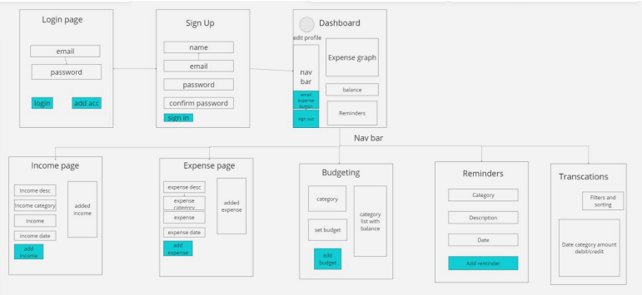

**• System Design**

System is designed to provide users with a comprehensive platform for managing their personal finances effectively.

It consists of five main modules: Dashboard, Income, Expense, Budgeting, Reminders and Investments.

The Dashboard serves as the central hub, offering users a quick overview of their financial status and activities. From here, users can access all other features and modules within the system.

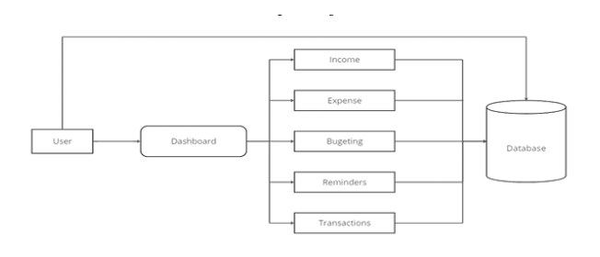

* **Authentication API**

The user is redirected to the Google OAuth page, where they are prompted to log in using their Gmail username and password.

Google provides a secure authentication interface where users can enter their credentials without exposing them to the application. Upon successful authentication, Google generates an OAuth token that represents the user's authorization to access their Gmail account.

This token serves as a credential that the application can use to access the user's account information on their behalf

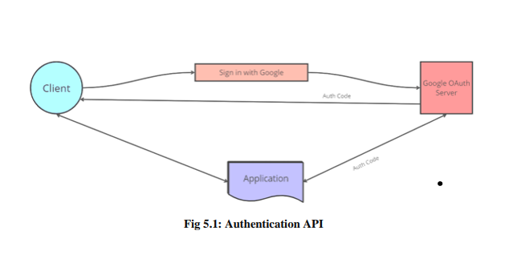

* **Reminder API**

Nodemailer is a widely-used module in Node.js for sending emails seamlessly within applications. It serves as a backbone for configuring and dispatching emails systematically, offering developers a comprehensive and flexible solution for email communication needs.

At its core, Nodemailer simplifies the process of sending emails by providing an intuitive and easy-to-use API. Developers can effortlessly integrate Nodemailer into their Node.js applications, allowing them to send transactional emails, notifications, verification emails, and more.

* **CRUD API**

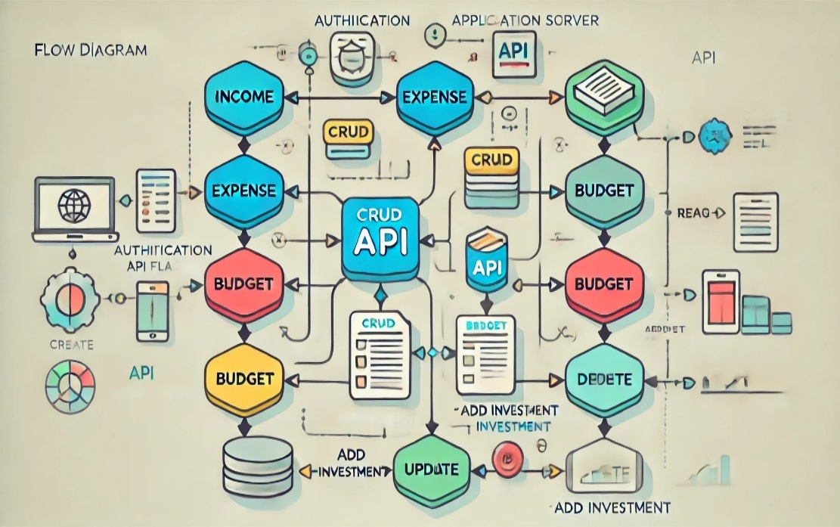

* **Income Module:**
  + POST /income: Create a new income entry.
  + GET /income: Retrieve a list of all income records.
  + PUT /income/{id}: Update a specific income entry.
  + DELETE /income/{id}: Delete an income entry**.**
* **Expense Module: Handles operations for tracking expenses:**
  + POST /expense: Create a new expense record.
  + GET /expense: Retrieve all expenses.
  + PUT /expense/{id}: Modify an expense entry.
  + DELETE /expense/{id}: Remove an expense record.
* **Budget Module: Manages budgets for financial planning:**
  + POST /budget: Define a new budget.
  + GET /budget: Fetch all defined budgets.
  + PUT /budget/{id}: Adjust an existing budget.
  + DELETE /budget/{id}: Delete a budget entry.
* **Add Investment Module: Tracks investments as part of financial planning:**
  + POST /investment: Add a new investment.
  + GET /investment: Retrieve all investment records.
* **Algorithm Implementation -**

**Email-Reminder:**In Pennytrack, the Email Reminder feature ensures users stay updated on their financial activities and obligations. It is an integral part of the system, designed to help users manage their budgets and expenses efficiently.

**Purpose:**

The email reminder feature aims to improve financial discipline by sending timely notifications for critical events, such as:

* Approaching Budget Limits: Alerts users when their spending nears or exceeds the budget.
* Upcoming Payments: Reminds users of due dates for bills, loans, or recurring subscriptions.
* Custom Alerts: Users can set reminders for personal financial tasks or milestones.

**How It Works:**

* Trigger Setup: Users configure reminders for specific financial events, such as budget thresholds or recurring payments.
* Notification API: The system uses tools like Nodemailer and SendGrid to deliver emails. These tools ensure secure and reliable delivery.
* Customizable Settings: Users can choose email frequency, types of alerts (e.g., daily, weekly), and personalized content for reminders.

**Benefits:**

* Avoid Late Payments: Prevents penalties or service interruptions by reminding users of due dates.
* Budget Control: Encourages users to manage expenses by sending alerts when overspending is detected.
* Financial Awareness: Keeps users informed about their financial status, promoting better decision-making.
* The email reminder feature integrates seamlessly with the overall functionality of Pennytrack, enhancing user experience and financial accountability**.**

**Budget Tracker:**

The Budget Tracker in Penny-track is a feature designed to help users set and manage their financial goals by providing a clear view of their spending habits and ensuring they stay within their predefined limits.

**Key Features:**

**Custom Budgets:**

Users can create budgets for various spending categories such as groceries, entertainment, utilities, and more. They can define specific budget limits based on their income and financial goals.

**Track Spending in Real-Time:**

The Budget Tracker automatically updates as users log their expenses. It compares their current spending to the predefined budget, offering an overview of how much they've spent and how much is remaining.

**Get Alerts and Notifications:**

When users approach or exceed their budget limits, they receive timely notifications. This helps them stay on track and make adjustments to avoid overspending. Notifications can be customized to alert users daily, weekly, or as they approach certain thresholds.

**Visualize Financial Trends:**

The system uses dynamic charts and graphs to provide users with a visual representation of their spending. This helps them easily identify areas where they may be overspending and areas where they could cut back.

**Track Budget Over Time:**

Users can set budgets for different time periods (e.g., weekly, monthly, or annually) and track their progress over time. This feature encourages long-term financial planning by allowing users to analyze trends and make necessary adjustments.

**How It Works:**

* **Budget Creation:** Users enter specific amounts for each category they want to track.
* **Expense Logging:** As users log each expense, the system automatically deducts the amount from the relevant budget category.
* **Real-Time Monitoring:** The system continuously compares actual spending with the budget, providing live updates.

Formula for Spent Amount Calculation:

$$Spent Amount= \sum_{t ϵ T_{c}}{t.amount}$$

$T_{c}: Transactions in category c$

$t.amount:Transaction amount$

Formula for Progress Calculation:

$$Progress\left(\%\right)=\left(\frac{Spent Amount}{Threshold Amount}\right) ×100$$

**Benefits:**

* **Stay Within Limits:** Helps users avoid overspending and manage their finances more effectively.
* **Financial Awareness:** Promotes better understanding of where money is going, helping users make informed financial decisions.
* **Encourages Saving**: By keeping track of budgets, users can adjust spending habits and work towards their financial goals, whether it's saving for a big purchase or reducing debt.

**Penny Drop:**

The **Penny Drop Algorithm** refers to a method often used in decision tree-based models to make decisions based on a sequence of events or actions that are incremental, like a penny gradually dropping and contributing to a larger change. In the context of decision trees, the **Penny Drop Algorithm** would involve evaluating conditions incrementally, where each step in the tree leads to a decision that influences the outcome, akin to a penny gradually adding up to a larger sum.

Here’s how the **Penny Drop Algorithm** could work within a **decision tree framework**:

**Description of the Penny Drop Algorithm in Decision Trees:**

* **Incremental Evaluation**:

Each decision point in the tree evaluates whether a small change (like a "penny dropping") should alter the path taken. This could represent small financial decisions, such as tracking spending or budgeting.

* **Node Representation**:

At each node in the decision tree, a test or condition is checked. For instance, a test might check if a certain threshold of spending has been reached. As more "pennies" are dropped (more data points or decisions are made), the decision tree gradually adapts to those changes.

* **Branching Decision**:

As each decision point ("penny") contributes incrementally, it pushes the model toward a final decision, just as small incremental changes build up to a larger effect. In a financial application, this could represent tracking small expenses that eventually trigger a recommendation or alert for the user.

* **Final Decision**:

Once the cumulative decisions (pennies) pass through all decision nodes, the final outcome is reached. This could be a recommendation, such as "budget exceeded," or a prediction about a user’s financial behaviour based on the accumulated data.

Formula for Decision Tree Classifier using Gini-Index:

$$Gini\left(S\right)=1- \sum_{i=1}^{k}{p_{i}^{2}}$$

$p_{i} is the proportion of class i in subset S$

* **Learning**:

The algorithm can learn from new data (pennies) by adjusting the tree structure over time, adapting to new trends, and refining the decisions made at each step.

**Example of Penny Drop in Financial Decision Trees:**

For a **budgeting application**, imagine a decision tree where:

* Each expense (a "penny") is evaluated against a budget threshold.
* If the accumulated expenses surpass a set limit, a new branch is triggered, leading to an alert or suggestion to adjust spending.
* The more data (pennies) are accumulated, the more the tree adjusts, identifying patterns of overspending.

**Key Points:**

* **Incremental Process**: Like pennies accumulating, small decisions or events gradually lead to a larger outcome.
* **Adaptive Decision-Making**: Decision trees can adapt and refine decisions as more data (pennies) flow through the system.
* **Cumulative Effect**: Just as a penny adds up over time, small financial decisions accumulate to influence the overall decision or outcome.

**Algorithm Flow Chart**

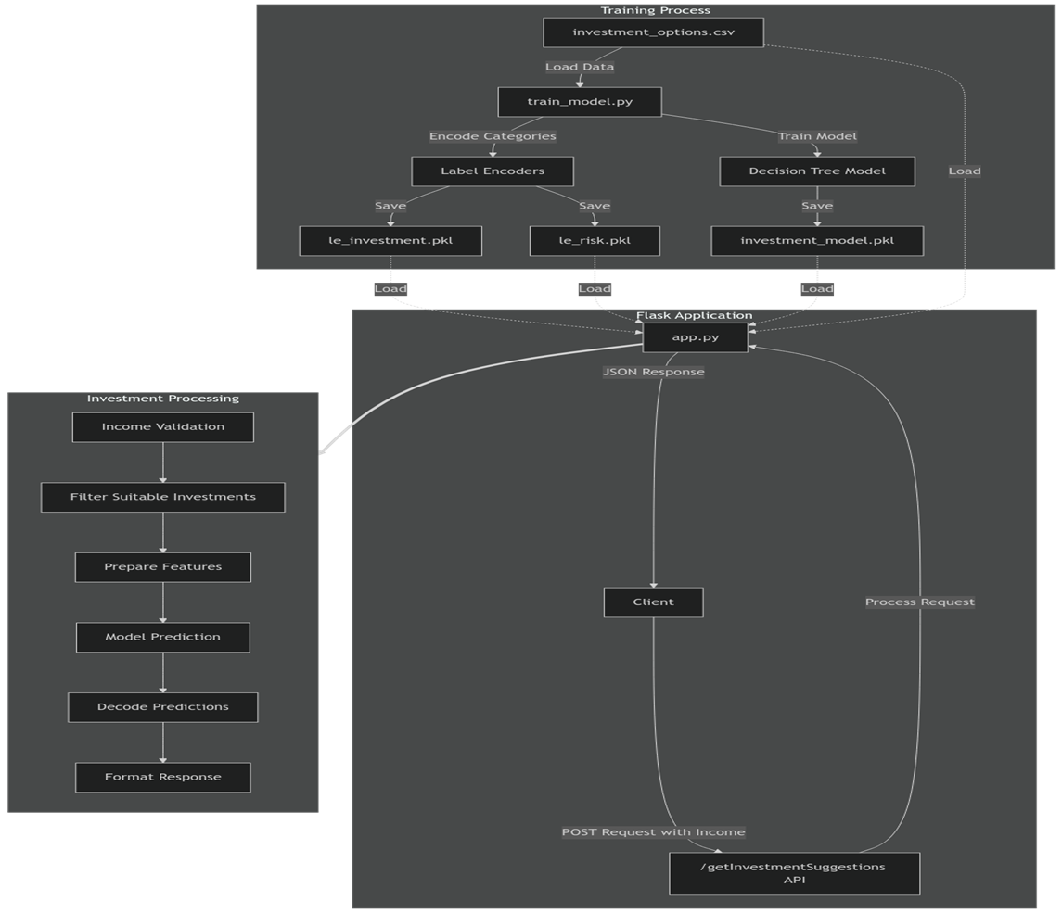

The architecture diagram illustrates a system for generating tailored investment suggestions by integrating a machine learning model with a Flask web application. The process begins with training a Decision Tree Model to analyze and predict suitable investment options based on user inputs. The application validates user income, filters appropriate investments, prepares the necessary features, and leverages the trained model to provide predictions. These predictions are then decoded and formatted into a user-friendly response, ensuring personalized and efficient investment recommendations. The modular structure ensures scalability, seamless data processing, and an enhanced user experience.

**CHAPTER-7**

**TIMELINE FOR EXECUTION OF PROJECT**

**(GANTT CHART)**

The Gantt chart for PennyTrack provides a structured timeline of key project milestones. It begins with the **0th Review on 14th September 2024**, focusing on finalizing the **project title and mapping it to relevant Sustainable Development Goals (SDGs)**. This initial phase was crucial for setting clear objectives and defining the project’s direction. The **1st Review on 21st October 2024** concentrated on completing the **project setup and implementing basic functionalities**, ensuring a solid foundation for further development. This stage covered backend configuration, frontend integration, and establishing core system operations.

Advancing further, the **2nd Review on 12th November 2024** involved a **partial demonstration** of the application along with a **draft report submission**. Key features like expense tracking, user authentication, and data visualization were highlighted during this phase. The **3rd Review on 17th December 2024** will present the **fully developed application** and **the final research paper**, showcasing advanced features such as AI-driven investment recommendations and enhanced security. Finally, the **4th Review on 10th January 2025** will focus on **Project Maintenance and Paper Publication**, ensuring the system’s stability, fixing any issues, and submitting the research paper for publication, marking the project’s completion and transition to long-term sustainability.

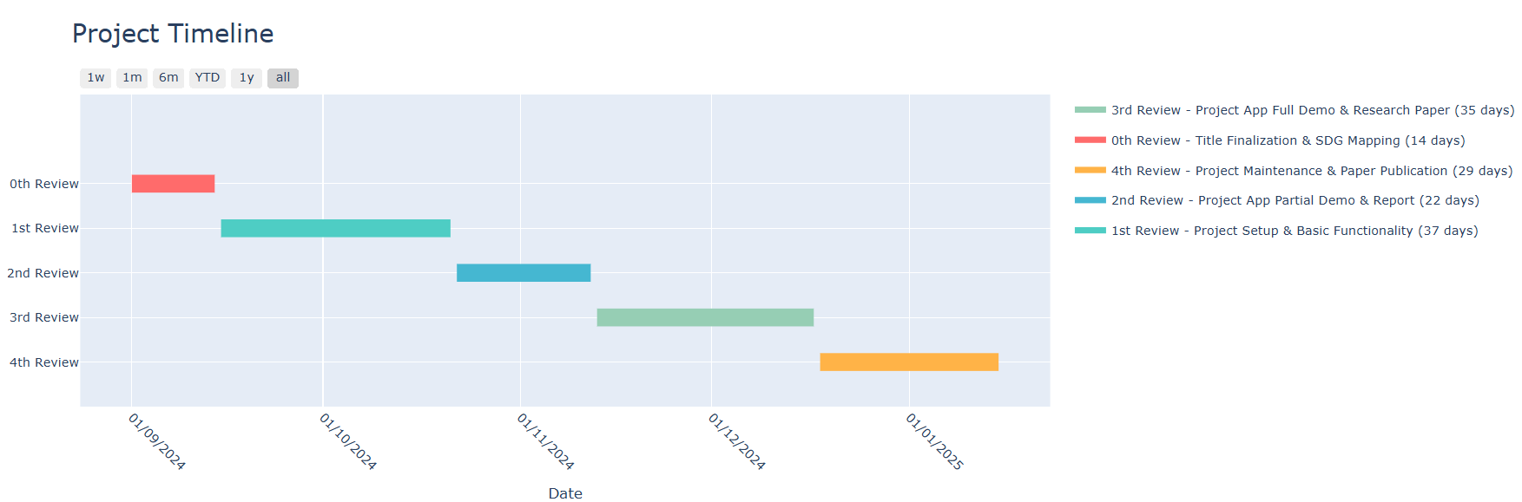

**CHAPTER-8**

**OUTCOMES**

* **Enhanced Financial Awareness:** Users gain insights into their spending habits, improving financial decision-making.
* **Simplified Expense Tracking:** Automated tracking reduces the need for manual entry in diaries or spreadsheets.
* **Consistent Budget Management:** Daily allowances are adjusted based on spending patterns to maintain a balanced budget.
* **Improved Financial Stability:** Informed financial choices help users avoid budget crises and foster long-term stability.
* **Better Organizational Financial Control:** Organizations benefit from systematic budgeting and expense management tools for better oversight.
* **User Satisfaction through Intuitive Design:** A user-friendly interface ensures ease of use and encourages regular engagement.
* **Increased Savings:** Automated savings tracking redirects unspent daily allowances into savings, promoting financial growth.
* **Goal-Oriented Financial Planning:** Users can set and track specific financial goals, such as saving for a major purchase or debt reduction, with progress indicators and milestone reminders to stay motivated.
* **Real-Time Financial Alerts:** Instant notifications for unusual spending patterns or upcoming due payments help users avoid overspending and late fees, ensuring proactive financial management.

**CHAPTER-9**

**RESULTS AND DISCUSSIONS**

The implementation of the Expense Tracker application demonstrates its effectiveness in addressing the limitations of traditional expense management methods. By replacing manual and error-prone processes with an intuitive Android-based solution, users experience enhanced financial awareness and simplified tracking. The automated daily and monthly budget adjustments ensure consistent financial stability, while features like real-time tracking and advanced analytics promote informed decision-making. Users reported increased savings through dynamic allowance recalculations and improved financial literacy via predictive tools and detailed visual reports. Organizations benefited from streamlined budgeting and oversight capabilities, enhancing cost management and operational efficiency. These outcomes validate the project's potential to revolutionize personal and organizational financial management, fostering better spending habits and financial control.

**Survey Insights:**

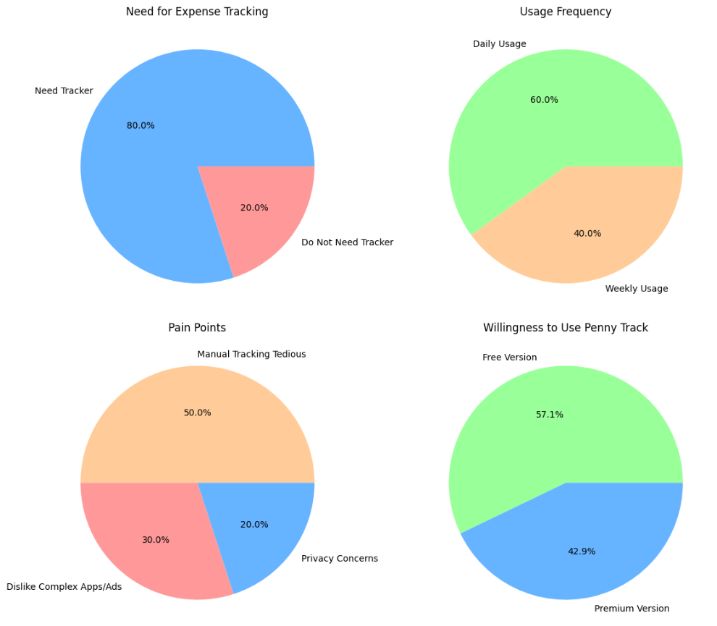

**CHAPTER-10**

**CONCLUSION**

The Expense Tracker project revolutionizes personal and organizational financial management by offering a user-friendly, Android-based solution that simplifies expense tracking. By automating the process, users can effortlessly monitor their income, expenses, and savings while gaining valuable insights into their spending habits. The application's predictive capabilities, customizable reports, and real-time financial feedback empower users to make informed decisions and maintain financial stability. For organizations, it streamlines budgeting and cost management, providing a clearer path to financial optimization. With its intuitive interface, scalability, and reliance on advanced technology, the Expense Tracker not only promotes responsible spending but also enhances financial literacy, making personal finance management accessible and engaging in the digital age. A standout feature of the application is the AI-powered PennyDrop investment recommendation system. This system uses machine learning algorithms, including a Decision Tree Classifier specifically (CART-Classification and Regression Tree), to provide tailored investment suggestions based on users’ financial data and risk tolerance. By analyzing income, expenditure patterns, and risk levels, PennyDrop empowers users to make informed investment decisions, aligning their financial goals with suitable opportunities.

The Expense Tracker also prioritizes data security and user privacy by implementing robust encryption protocols and secure authentication mechanisms. Users can confidently manage their financial information, knowing their sensitive data is well-protected. Additionally, the app offers seamless integration with banking services and third-party financial tools, ensuring a comprehensive overview of financial health. Regular updates and personalized notifications keep users engaged and informed about upcoming bills, saving goals, and investment opportunities. Its adaptive design caters to both individual users and businesses, supporting multi-account management and collaborative budgeting. By combining convenience, security, and intelligent insights, the Expense Tracker fosters long-term financial well-being and growth.

**REFERENCES**

[1] A. Manchanda, Expense Tracker Mobile Application, IEEE, 2012.

[2] G. Bekaroo and S. Sunhaloo, Intelligent Online Budget Tracker, IEEE, 16 June 2014.

[3] N. Jagtap, P. Joshi, and A. Kamble, A Review on Budget Estimator Android Application, IEEE, April 2019.

[4] H. Gupta, A. P. Singh, N. Kumar, and J. A. Blessy, Expense Tracker: A Smart Approach to Track Everyday Expense, IEEE, 25 December 2020.

[5] V. Geetha, G. Nikhitha, H. S. Lasya, and C. K. Gomathy, Expenditure Management System, IEEE, 16 May 2022

[6] A. Sharma et al., “Personal Finance Management Using Machine Learning,” 2020.

[7] R. Verma and S. Kumar, “Design and Development of an Expense Tracker Using IoT,” 2021.

[8] M. Singh et al., “Expense Tracking and Budgeting System Using Big Data,” 2019.

[9] H. Gupta and N. Patel, “Cloud-Based Expense Management for Personal Finance,” 2020.

[10] S. Kumar and R. Tiwari, “Development of an Automated Personal Finance Management Application,” 2022.

**APPENDIX-A**

**PSUEDOCODE**

**Email Reminder:**

**remainder.controller.js:**

import { asyncHandler } from "../utils/asyncHandler.js";

import { ApiError } from "../utils/ApiError.js";

import { Reminder } from "../models/reminder.model.js";

import { User } from "../models/user.model.js";

import { sendEmail } from "../services/email.service.js";

const createReminder = asyncHandler(async (req, res) => {

const { title, amount, date } = req.body;

if (!title.trim()) throw new ApiError(400, "All fields are required");

const reminder = await Reminder.create({

title,

amount,

date,

user: req.user._id,

});

const user = await User.findById(req.user._id);

sendEmail(user.email, "Reminder", `You have a reminder for ${title} on ${date}`);

return res.status(201).json({ status: 201, data: reminder, message: "Reminder created successfully" });

});

const getReminder = asyncHandler(async (req, res) => {

const reminder = await Reminder.find({ user: req.user._id, isDeleted: false });

return res.status(200).json({ status: 200, data: reminder, message: "Reminder retrieved successfully" });

});

export { createReminder, getReminder };  
  
**email.service.js:**

import nodemailer from "nodemailer";

import { asyncHandler } from "../utils/asyncHandler.js";

const transporter = nodemailer.createTransport({

service: "gmail",

auth: {

user: process.env.EMAIL_ADDRESS,

pass: process.env.EMAIL_PASSWORD,

},

});

const sendEmail = asyncHandler(async (toEmail, subject, text) => {

try {

await transporter.sendMail({ from: process.env.EMAIL_ADDRESS, to: toEmail, subject, text });

} catch (error) {

console.error("Error sending reminder email:", error);

}

});

export { sendEmail };

**Budget Tracker, Progress Bar and Pie Chart :**

**Data Fetching and Calculation Functions:**

import React, { useState, useEffect } from "react";

import axios from "axios";

export default function Budgeting() {

const [budget, setBudget] = useState([]);

const [transactions, setTransactions] = useState([]);

useEffect(() => {

const fetchData = async () => {

const accessToken = localStorage.getItem("accessToken");

if (!accessToken) return;

try {

const budgetResponse = await axios.post(`${process.env.NEXT_PUBLIC_BACKEND_URL}/budget/getBudget`, {}, { headers: { Authorization: `Bearer ${accessToken}` } });

const transactionResponse = await axios.post(`${process.env.NEXT_PUBLIC_BACKEND_URL}/transactions/getTransaction`, {}, { headers: { Authorization: `Bearer ${accessToken}` } });

if (budgetResponse.data.success) setBudget(budgetResponse.data.data);

if (transactionResponse.data.success) setTransactions(transactionResponse.data.data);

} catch (error) {

console.error("Error fetching data:", error);

}

};

fetchData();

}, []);

// Calculate total spent for each category

const getCategorySpentAmount = (category) => transactions

.filter((t) => t.transaction_category === category)

.reduce((total, t) => total + t.transaction_amount, 0);

// Calculate progress for each category based on the threshold amount

const getCategoryProgress = (category) => {

const budgetItem = budget.find((b) => b.budget_category === category);

return budgetItem ? (getCategorySpentAmount(category) / budgetItem.threshold_amount) * 100 : 0;

};

// Check if the amount crossed the budget amount

const isBudgetExceeded = (category) => {

const budgetItem = budget.find((b) => b.budget_category === category);

return getCategorySpentAmount(category) > (budgetItem ? budgetItem.budget_amount : 0);

};

**Rendering the Budget Tracker UI:**

return (

<div className="w-1/2">

<div className="bg-[#1d1d1d] w-full h-full p-8 rounded-xl">

<h1 className="text-3xl text-light-green-500 font-medium">Budget Tracker</h1>

{budget.map((item) => (

<div key={item._id} className="my-4">

<h2 className="text-xl text-white font-semibold">{item.budget_title}</h2>

<p className="text-sm text-gray-400">{item.budget_description}</p>

<p className="text-sm text-gray-400">Budget: ₹{item.budget_amount}</p>

<div className="h-4 bg-gray-300 rounded-full mt-2">

<div

className="h-full bg-light-green-500 rounded-full"

style={{ width: `${getCategoryProgress(item.budget_category)}%` }}

></div>

</div>

<p className="text-xs text-gray-400 mt-1">Spent: ₹{getCategorySpentAmount(item.budget_category)}</p>

{isBudgetExceeded(item.budget_category) && (

<p className="text-xs text-red-500 mt-1">Budget Exceeded!</p>

)}

</div>

))}

</div>

</div>

);

}

**PennyDrop:**

**train_model.py:**

import pandas as pd

from sklearn.tree import DecisionTreeClassifier

from sklearn.preprocessing import LabelEncoder

import joblib

# Load the dataset and encode categorical variables

df = pd.read_csv('investment_options.csv')

le_investment = LabelEncoder()

df['InvestmentCode'] = le_investment.fit_transform(df['InvestmentOption'])

le_risk = LabelEncoder()

df['RiskCode'] = le_risk.fit_transform(df['RiskLevel'])

# Features and target

X = df[['MinIncome', 'MaxIncome', 'RiskCode', 'MaxPotentialLoss']]

y = df['InvestmentCode']

# Train model and save it

model = DecisionTreeClassifier()

model.fit(X, y)

joblib.dump(model, 'investment_model.pkl')

joblib.dump(le_investment, 'le_investment.pkl')

joblib.dump(le_risk, 'le_risk.pkl')

print("Model and encoders have been saved.")

**app.py:**

from flask import Flask, request, jsonify

import joblib

import pandas as pd

from flask_cors import CORS

app = Flask(__name__)

CORS(app)

# Load model and encoders

model = joblib.load('investment_model.pkl')

le_investment = joblib.load('le_investment.pkl')

le_risk = joblib.load('le_risk.pkl')

# Load dataset and encode columns

df = pd.read_csv('investment_options.csv')

df['InvestmentCode'] = le_investment.transform(df['InvestmentOption'])

df['RiskCode'] = le_risk.transform(df['RiskLevel'])

@app.route('/getInvestmentSuggestions', methods=['POST'])

def get_investment_suggestions():

data = request.get_json()

income = data.get('income')

if not income or not income.isdigit():

return jsonify({'error': 'Valid income is required.'}), 400

# Filter investments by income range

suitable_investments = df[(df['MinIncome'] <= float(income)) & (df['MaxIncome'] >= float(income))]

if suitable_investments.empty:

return jsonify({'message': 'No suitable investments.'}), 404

# Prepare input features for prediction

X_new = suitable_investments[['MinIncome', 'MaxIncome', 'RiskCode', 'MaxPotentialLoss']]

predicted_codes = model.predict(X_new)

# Decode and return suggestions

predicted_options = le_investment.inverse_transform(predicted_codes)

**APPENDIX-B**

**SCREENSHOTS**

**Landing Page**

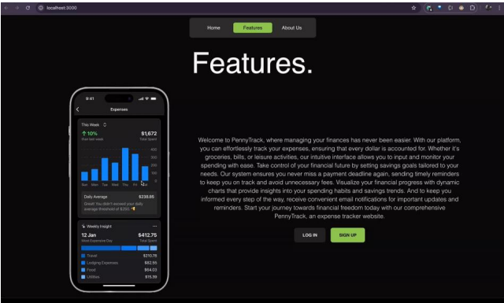

**• Authentication Pages**

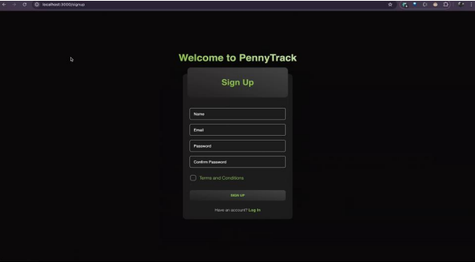

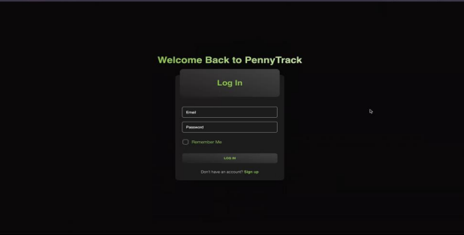

**• User Dashboard Page**

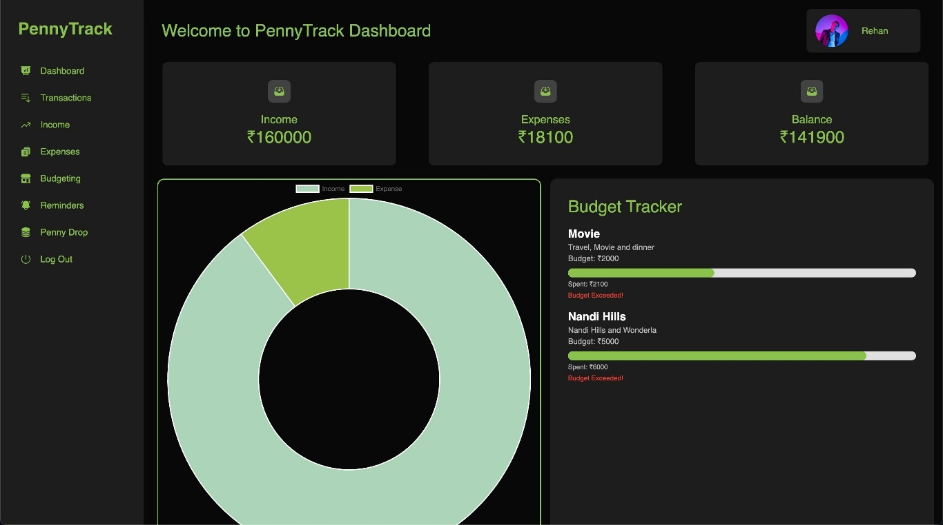

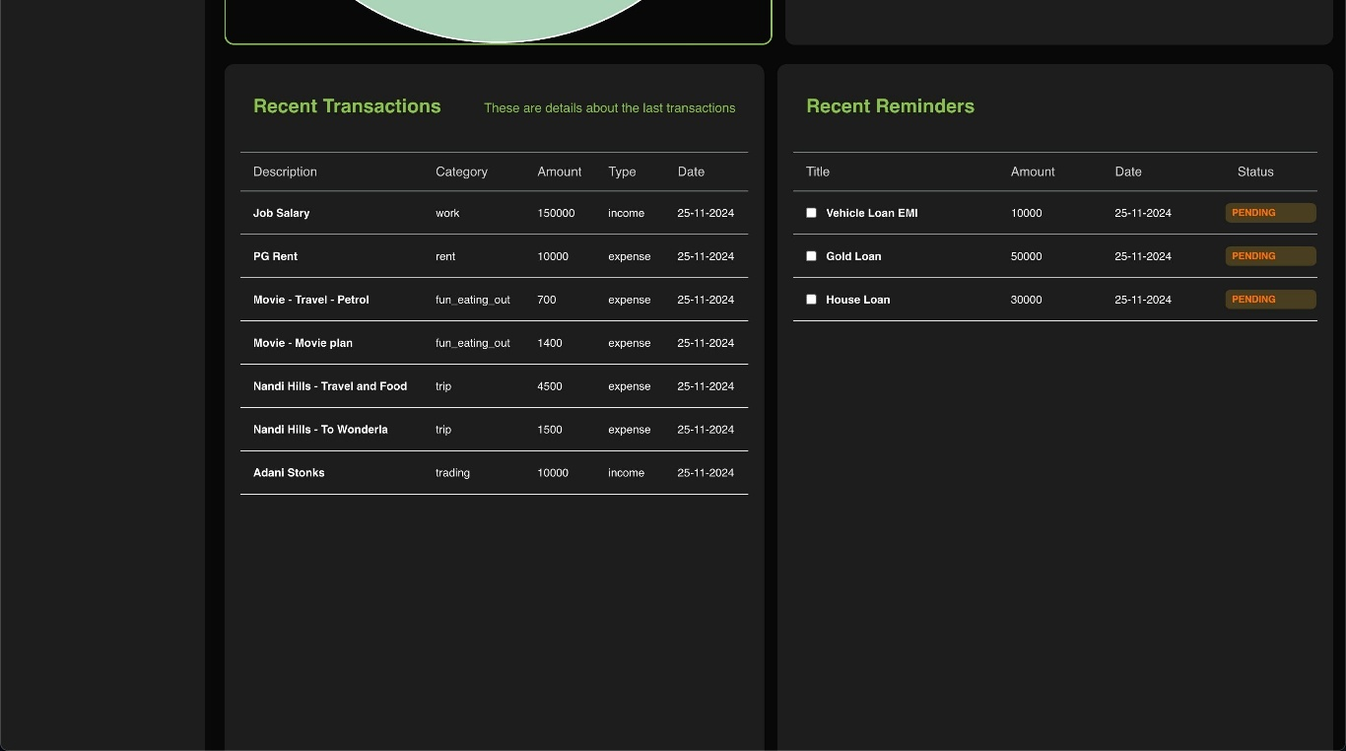

**• Income Page**

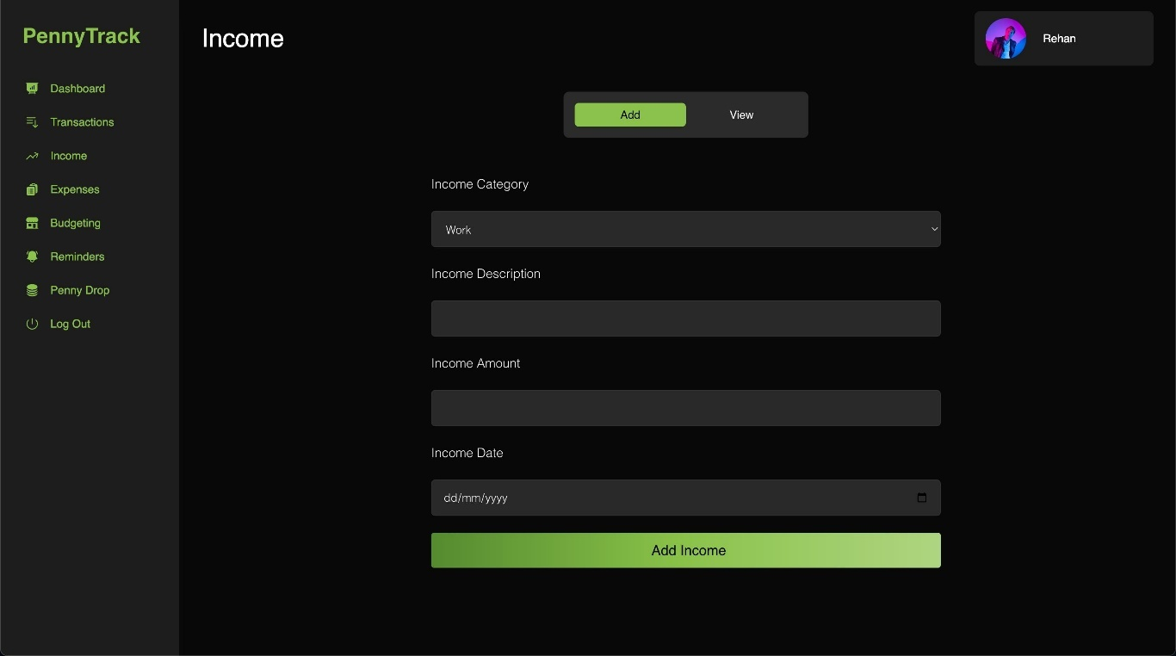

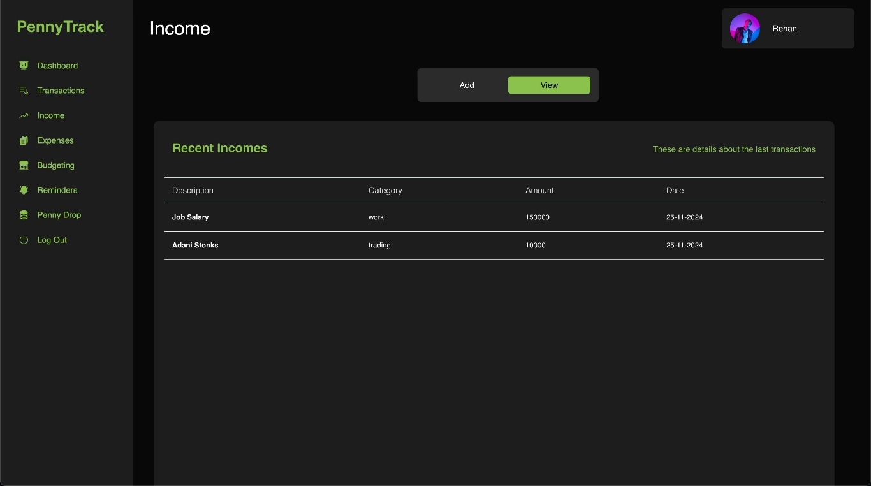

**• Expense Page**

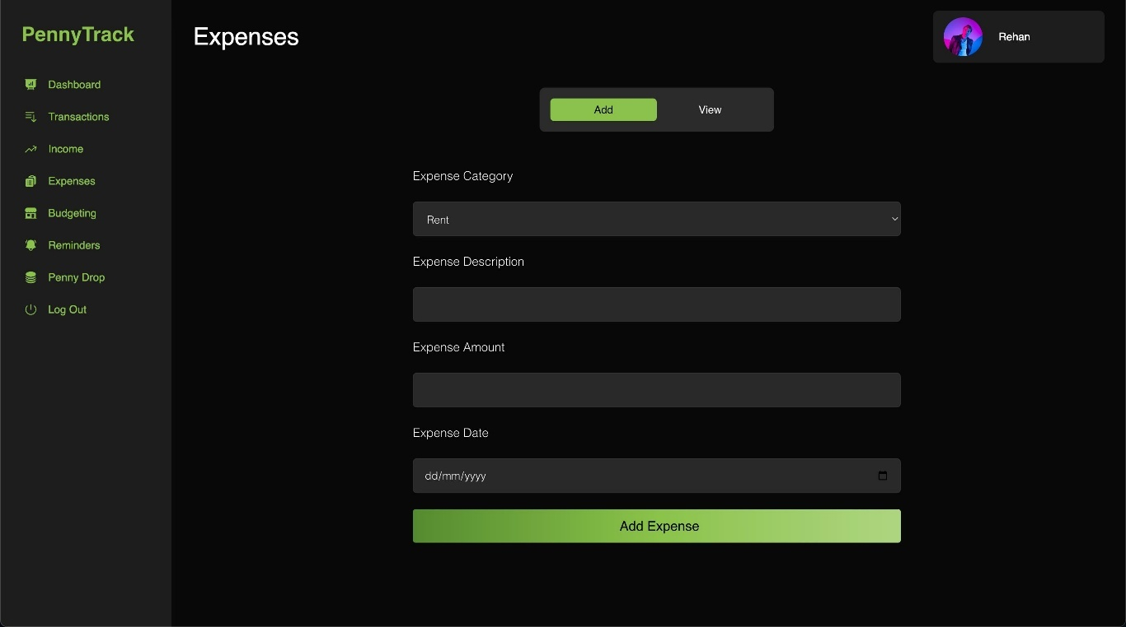

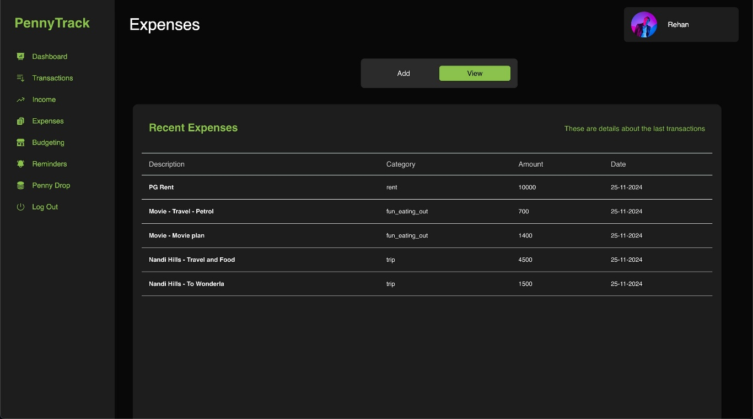

**• Budgeting Page**

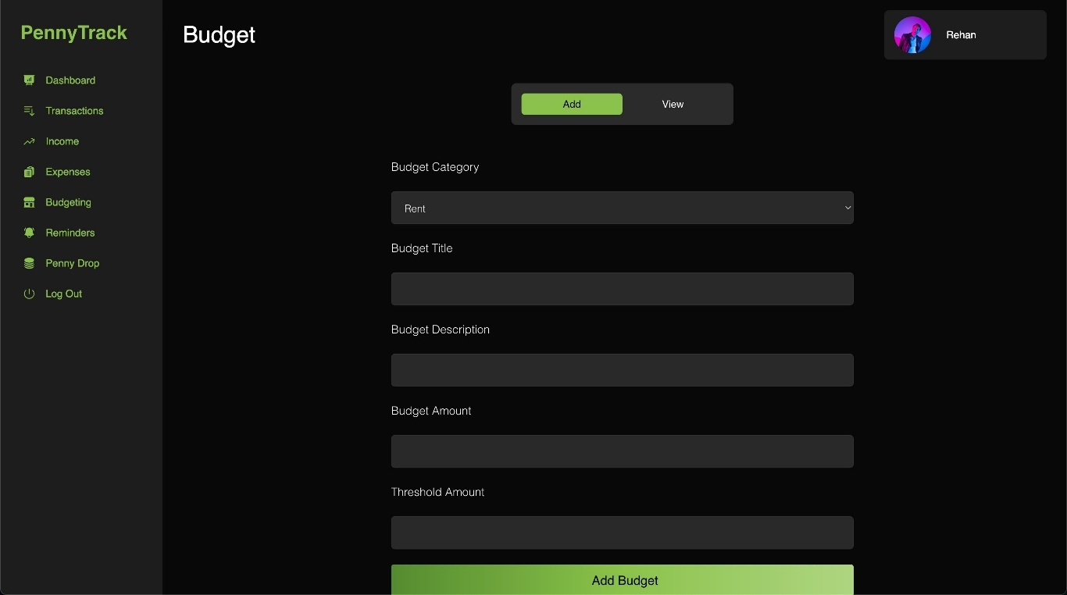

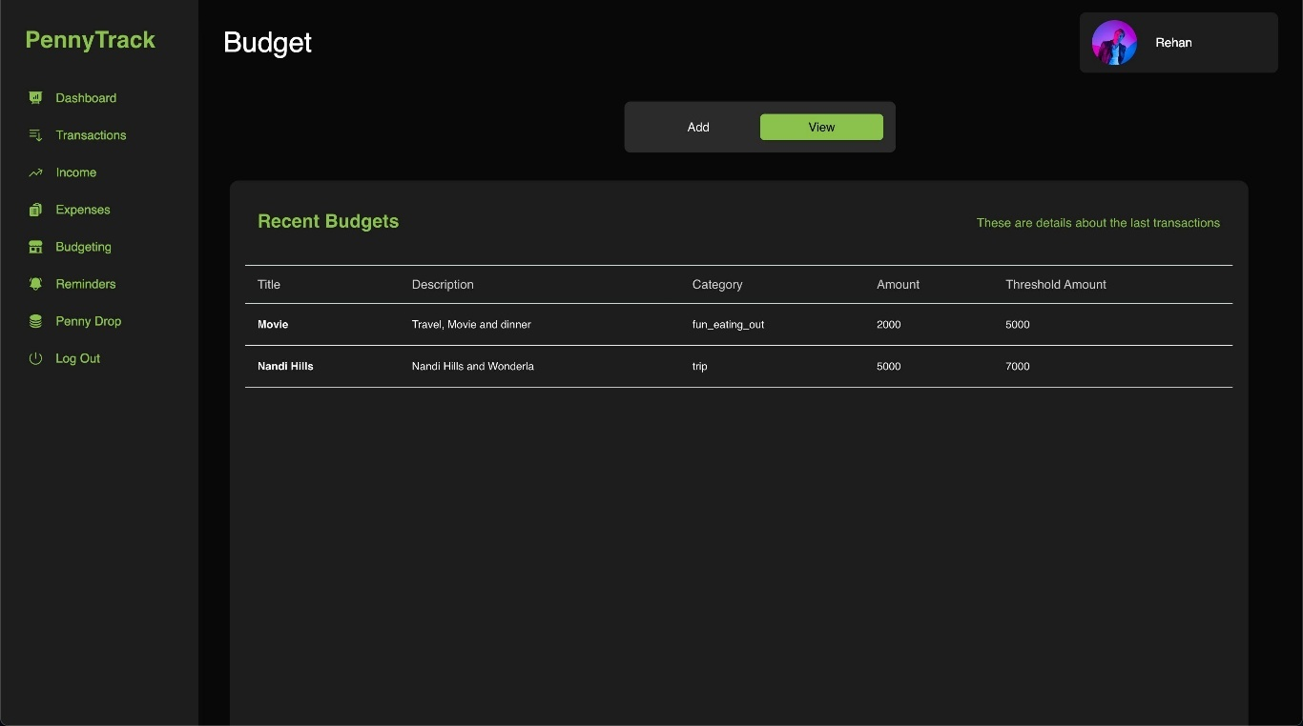

* **Reminder**

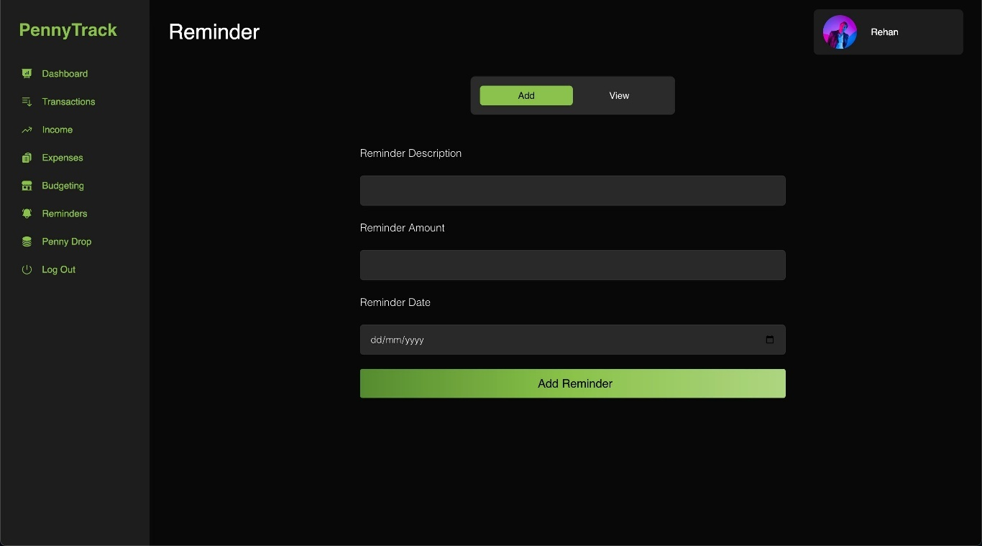

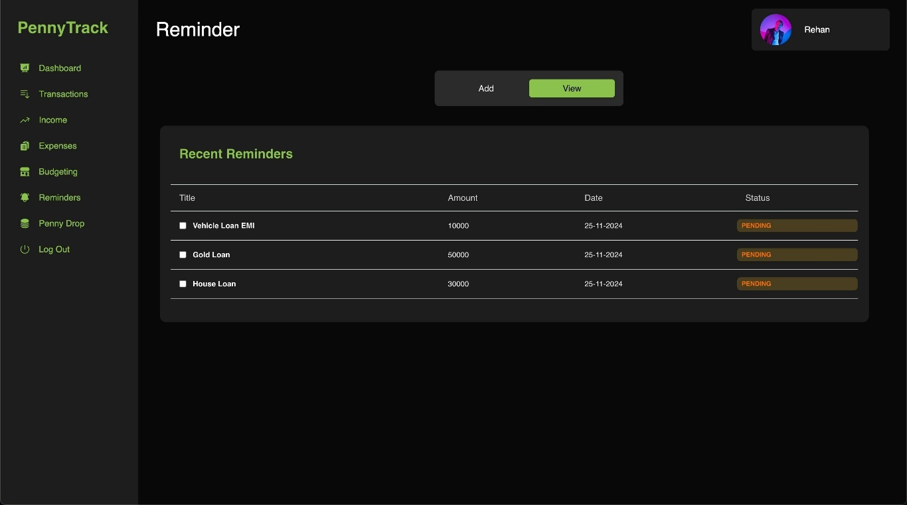

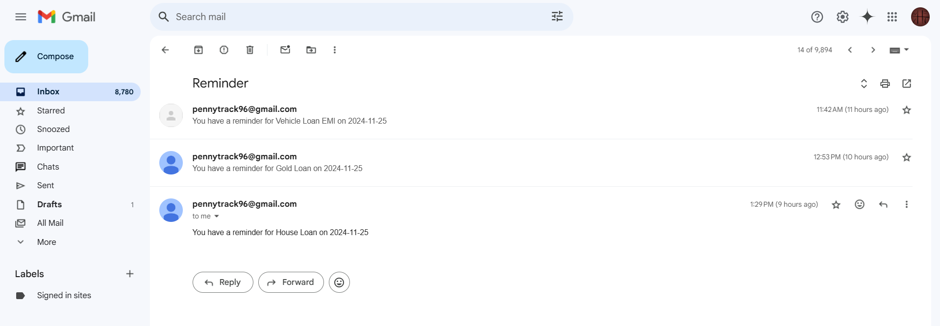

* **PennyDrop - CART powered Recommendation System for Investment Suggestions** 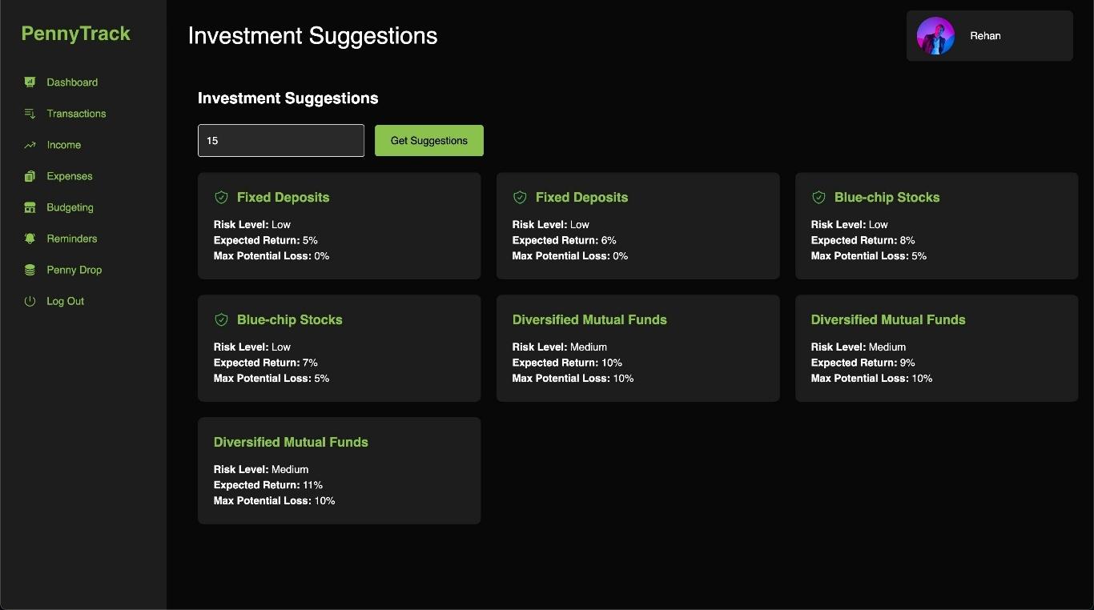

**APPENDIX-C**

**ENCLOSURES**

**1. Journal publication/Conference Paper Presented Certificates of all students.**

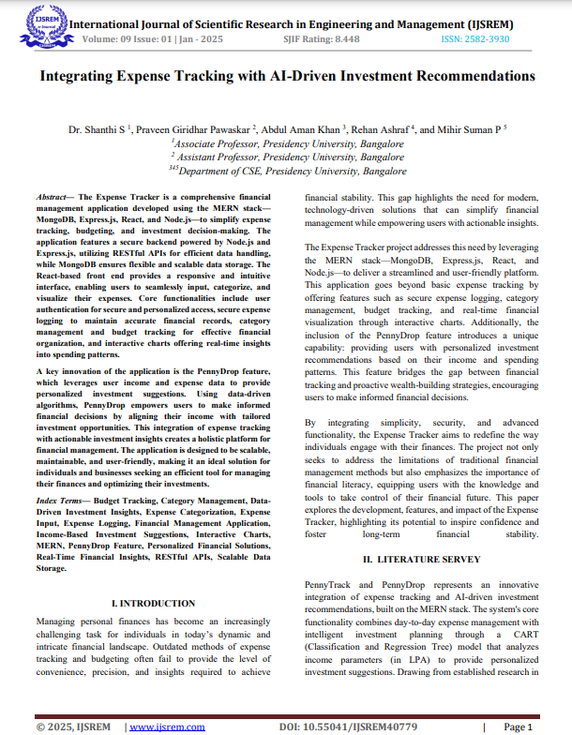

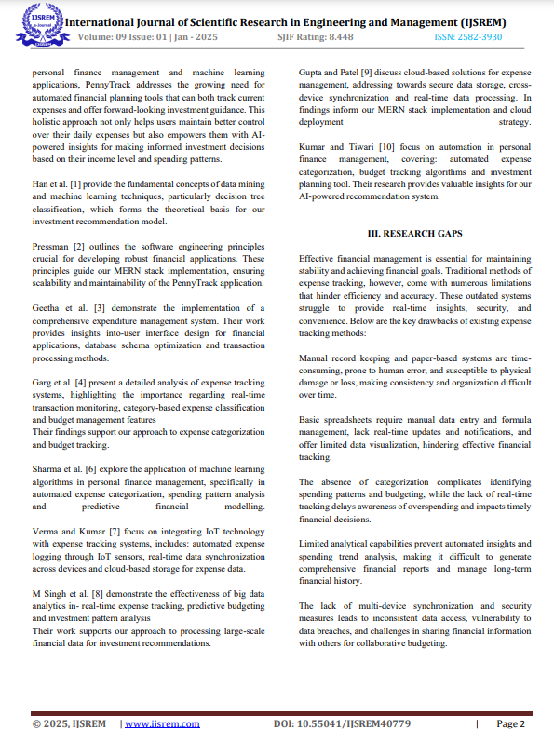

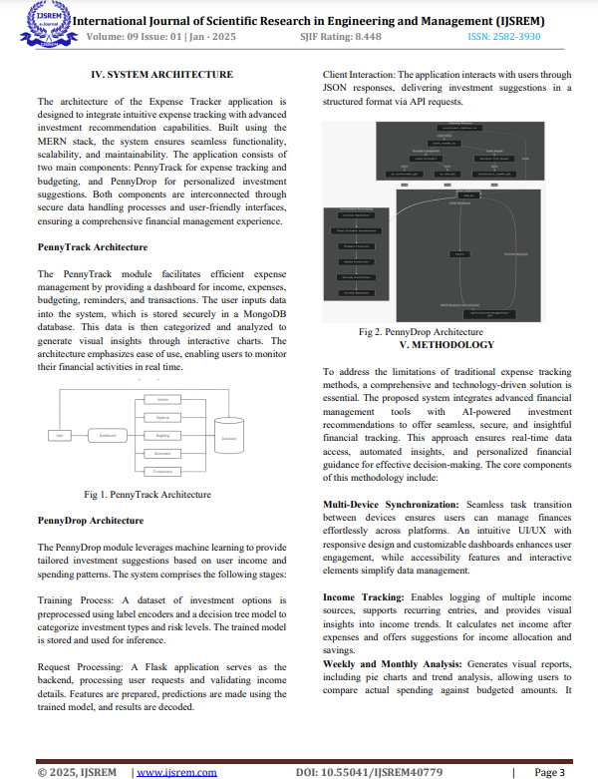

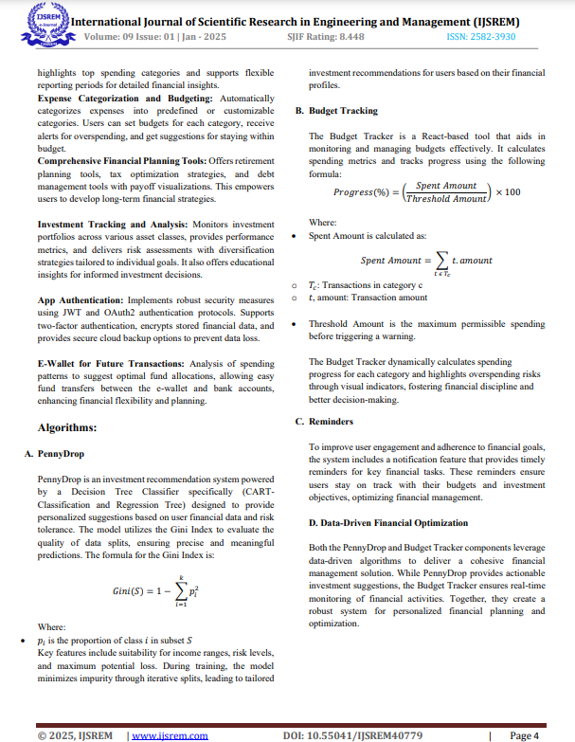

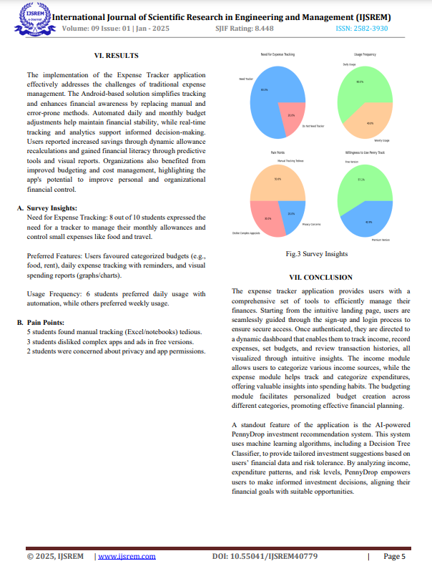

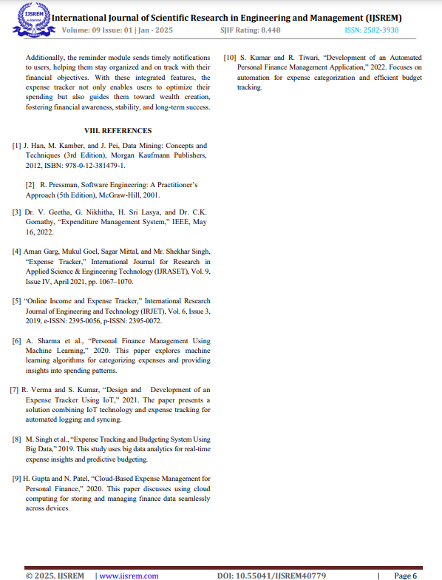

**2.** **Include certificate(s) of any Achievement/Award won in any project-related event.**

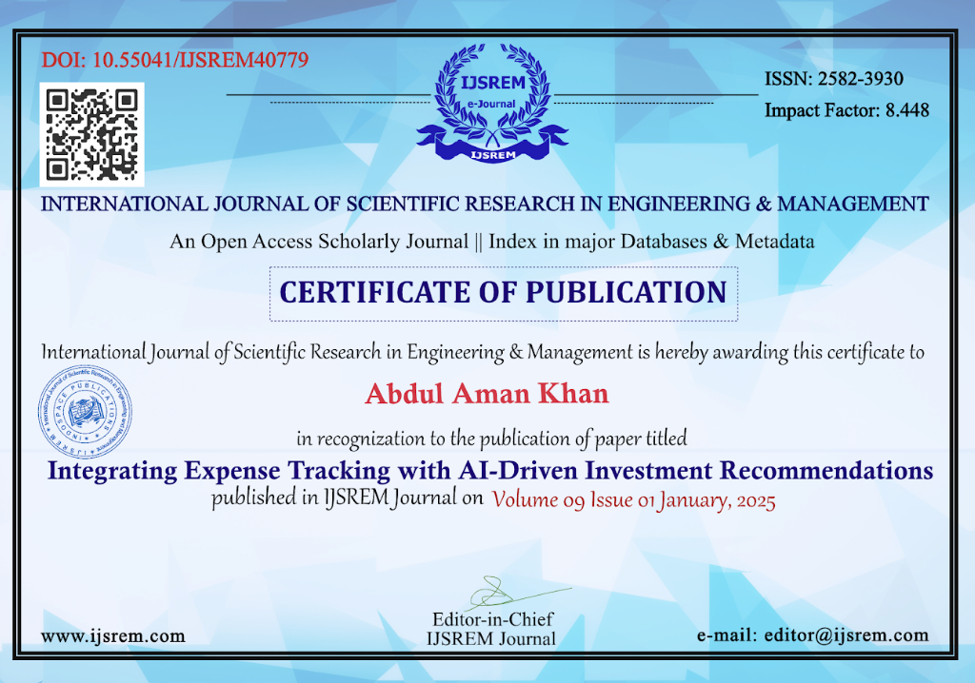

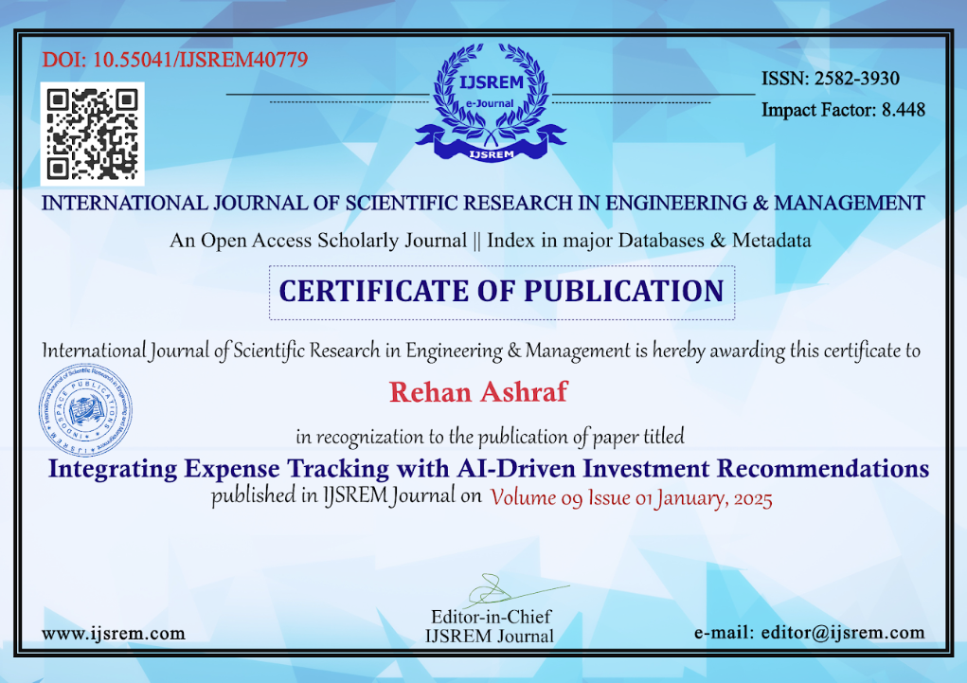

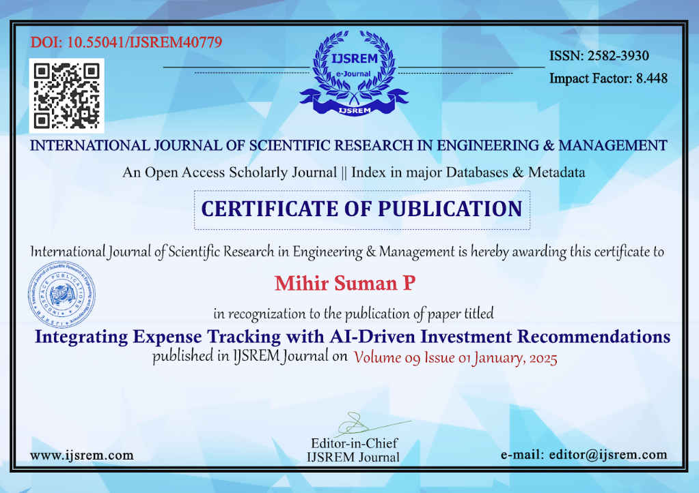



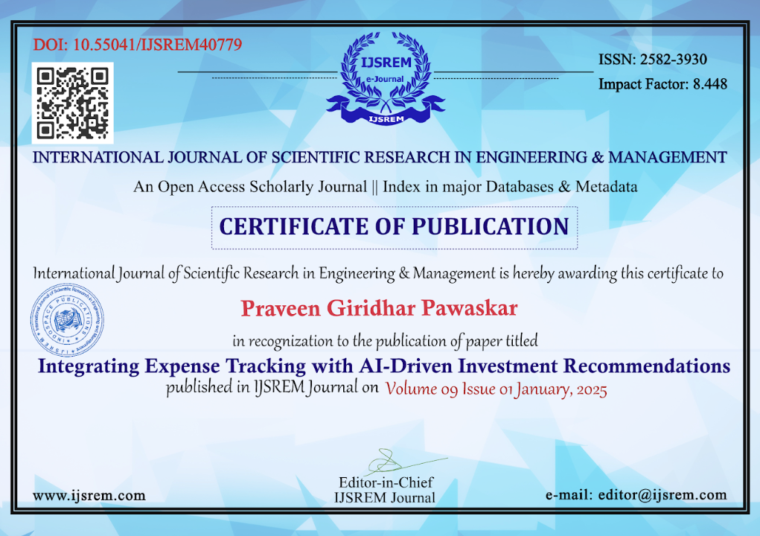

**3. Similarity Index / Plagiarism Check report clearly showing the Percentage (%). No need for a page-wise explanation.**

**Capstone Project Report:**

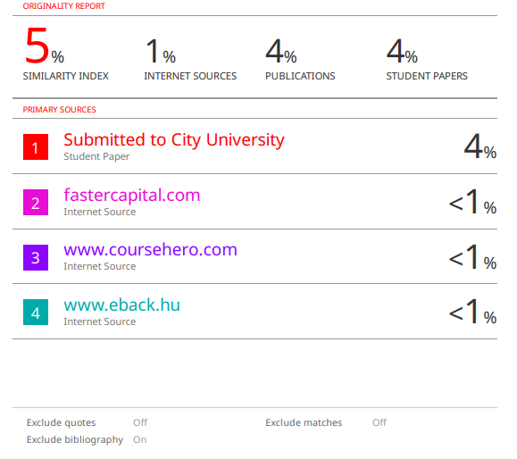

**Capstone Project Research Paper:**

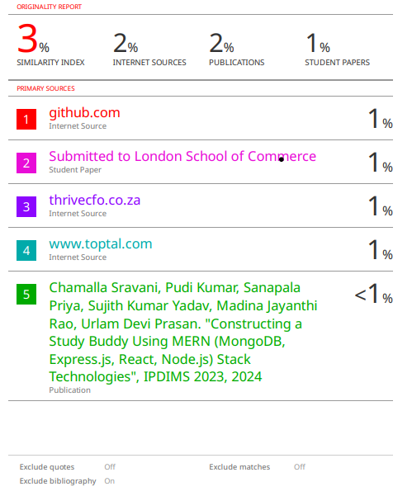

**4.** **Details of mapping the project with the Sustainable Development Goals (SDGs).**

Mapping the Expense Tracker Project to Sustainable Development Goals (SDGs)

The Expense Tracker project addresses several SDGs by promoting financial literacy, reducing inequalities, and fostering economic well-being. Below is the detailed mapping:       



**SDG 1: No Poverty**

Target 1.4: Ensure access to economic resources, financial literacy, and decision-making tools.

The application empowers users to track expenses, manage budgets, and make informed financial decisions, reducing poverty through better financial planning.

**SDG 3: Good Health and Well-being**

Target 3.4: Promote mental well-being by reducing financial stress.

Financial challenges are a significant source of stress. The Expense Tracker provides tools to monitor spending and align financial goals, contributing to reduced anxiety and improved mental health.

**SDG 4: Quality Education**

Target 4.4: Increase the number of individuals with relevant skills, including financial literacy.

By offering an intuitive platform for expense tracking and investment guidance, the project enhances users’ understanding of financial management and encourages lifelong learning in financial literacy.

**SDG 5: Gender Equality**

Target 5.5: Ensure women's equal opportunities for financial independence and economic participation.

The Expense Tracker promotes financial autonomy by equipping users, including women, with tools to take control of their finances and make informed decisions.

**SDG 8: Decent Work and Economic Growth**

Target 8.3: Support entrepreneurship and promote access to financial services.

The application’s investment suggestion feature enables individuals to grow their financial resources, supporting economic activities and fostering entrepreneurial ventures.

**SDG 10: Reduced Inequalities**

Target 10.2: Empower individuals from marginalized communities by improving access to financial management tools.

With its scalable and user-friendly design, the application ensures inclusivity, providing everyone, irrespective of background, the means to manage their finances effectively.

**SDG 12: Responsible Consumption and Production**

Target 12.8: Promote awareness of sustainable consumption.

The application’s interactive charts and spending insights encourage responsible financial habits, aligning personal consumption with long-term sustainability goals.

**SDG 16: Peace, Justice, and Strong Institutions**

Target 16.7: Ensure responsive and inclusive decision-making.

By offering real-time financial insights, the Expense Tracker facilitates transparent and informed decision-making, fostering trust and accountability in personal finance.

**SDG 17: Partnerships for the Goals**

Target 17.16: Strengthen global partnerships to enhance financial literacy.

The project can collaborate with financial institutions, NGOs, and educational organizations to promote financial literacy and inclusivity.